A PRESENTATION

**Listening:** You are going to listen to Leroy and Cheryl talking about a presentation.

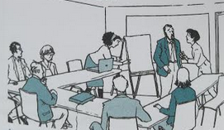**1**. Look up how these are called in English:

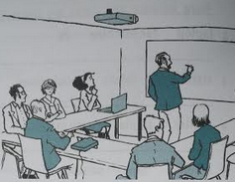

**2.** Look at the following words that can be used when talking about a presentation and underline or highlight the ones you hear. Look up the ones you don't know to find the French equivalent.

**chart - diagram - flip chart - graph - handouts - key points - markers - outline - pointer - projector - screen -**

**slides - summary - topic - visual aids - whiteboard - audience -**

3. Listen to the conversation again if needed and answer the questions:

a. List all the problems the speaker encountered: ______________________________

b. What is the problem with the projector? _____________________________________

c. What was the problem with the markers? ____________________________________

d. What are the two solutions Leroy comes up with? ______________________________

e. Why do they say the presenter was well-prepared? ________________________________

**3.** Complete this summary with words from the conversation:

The Metal Works _________________ gave a presentation but a lot went wrong: The _______________ wouldn't work (the __________________ is out), he didn't have any ____________________ to enable people to have a visual, and all the _______________________ pens were dry! However, the presentation was very entertaining, Bernie used a ____________

and he made funny comments while he was drawing. The speech was neither boring nor too conventional because it was ______________.

**4. A.** Choose a word or expression from the list below to complete these sentences from the conversation:

**and - but - or - so - such - as - such as - too - enough - still - yet - already**

a. You mean our projector hasn't been fixed _________?

b. Lucy ran to the supply room to get new ones _______ she discovered that we only had permanent markers.

c. So, I got out a flipchart _______ Lucy had _______ brought a set of markers

d. Wouldn't it have been better to postpone the presentation ________ send someone out to buy new pens?

e. Well, Bernie was _____ there, wasn't he?

f. The pictures were drawn ______ quickly and the comments were _______ funny that we couldn't stop laughing!

g. The speech was spontaneous _______ to keep our interest and not ______ conventional.

**4. B.** Complete these sentences using the words you used in 4.A.:

_______: indicates whether a situation has changed or is expected to change.

_______: indicates an addition

_______: shows contrast

_______: indicates a sufficient amount and _______ indicates more than a reasonable amount.

_______: is used with an adverb.

_______: shows two options.

**Grammar:** Read the lesson about linking words below.

Complete the sentences with a word or expression from the list below:

**and - but - or - so - such - as - such as - too - enough - still - yet - already – also – as well as**

a. The customer wanted to return the dress ____ buy a suit.

b. Was the conference postponed ____ cancelled?

c. Mr Lee wanted to have the meeting today ____ several people were out of the office.

d. He ____ wanted to have a new laptop!

e. Sue is going to the trade show ____ will give a presentation there.

f. You could go to lunch early ___ wait until after the meeting for lunch.

g. Our profits are up, ____ the outlook is still uncertain.

h. Could you bring me some paper clips ____ a box of staples?

i. Andrea wanted to invest in the company ____.

j. The service in this restaurant was ___ unpleasant that we can't recommend it.

k. It was hard to hear the talk because the presenter spoke ___ quietly.

l. I have never attended ____ a motivating conference before.

m. Our company has outlet in several cities, ____ Paris, Tokyo and New York.

n. A company can never do _____ to attract and retain talented personnel.

o. Sam doesn't have ____ self-motivation to be really successful in his job.

p. Although it paid well, my factory job was too repetitive, ___ I quit.

q. Jim is _____ planning to give a presentation on this product but it is not ready ___. But he has ____ prepared a slide show of the development process.

r. "How do you think the presentation went? " "____ a visitor knowing nothing about that topic, I can say I learned quite a lot!" "I agree and I have never thought of those points before, ____ the way you can restructure departments. It gave me a lot to think about."

# LINKING WORDS

From *Grammar and Vocabulary for the TOEIC Test,* Cambridge

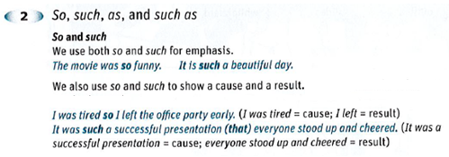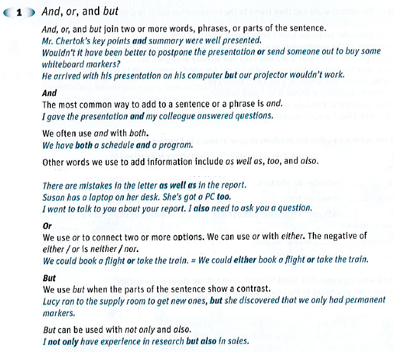

**Vocabulary**

1. Match the words from the first column with their meaning in the second column. Write the corresponding letter in the box:

Charts and graphs are a. the essential ideas in a presentation

Flipcharts and whiteboards are b. the people who attend the presentation.

Laser pointers are c. equipment to write information on.

The audience are d. hand-held objects used to show something on a screen.

Key points are e. pictures of data

2. Cindy's colleagues gave her the following feedback after she practiced giving her presentation to her coworkers. Complete the conversation using the words below:

**audience - graphs - handouts - key points - screen - outline - visual aids - summary - projector - slides**

Your information was well-organized. You gave a nice overview and showed the important features of our services. However, you wrote too much information on each of your _________. We read that information instead of listening to your talk. For the same reason, I suggest that you distribute your ________ after the talk. You read through your presentation instead of talking to your _______. I suggest that you just make an _____ on note cards and make sure you make eye-contact with the audience.

Your ____ were attractive and showed up nicely on the _______, but in one case you had too many ____ on one slide. They were too small to be seen properly. Decide which ones show the ______ most effectively, make them bigger, and show them one at a time. Delete the ones that are secondary. You made a nice ____ of all the points at the end.

One last thing, don't forget to call the conference center and make sure that they've got a ____ in the room you'll be using.

3. Look at these sets of words. Cross out the one that doesn't belong in each set and explain why in a few words:

1. marker computer microphone projector

2. slides expectations visual aids handouts

3. pointer chart graph diagrams

4. audience viewers listeners presenters

5. whiteboard flip chart outline screen

6. summary key points topic handouts